Usage based optimization walk through

First make sure your connection is set up in your SSAS MD settings:

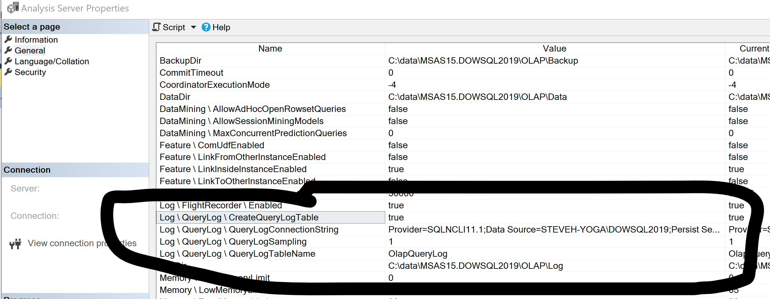

I pointed mine to the WideWorldImportersDW databases per my instructions in the callout. You will know it works AFTER you run some queries in the cube. It will create the table as shown here:

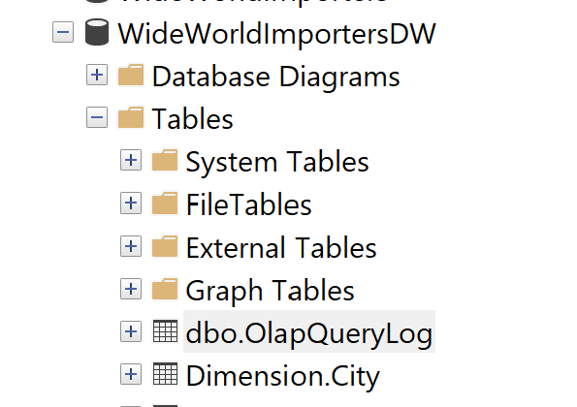

Once that has happened you can run the steps in the chapter. Here are all the screens in order

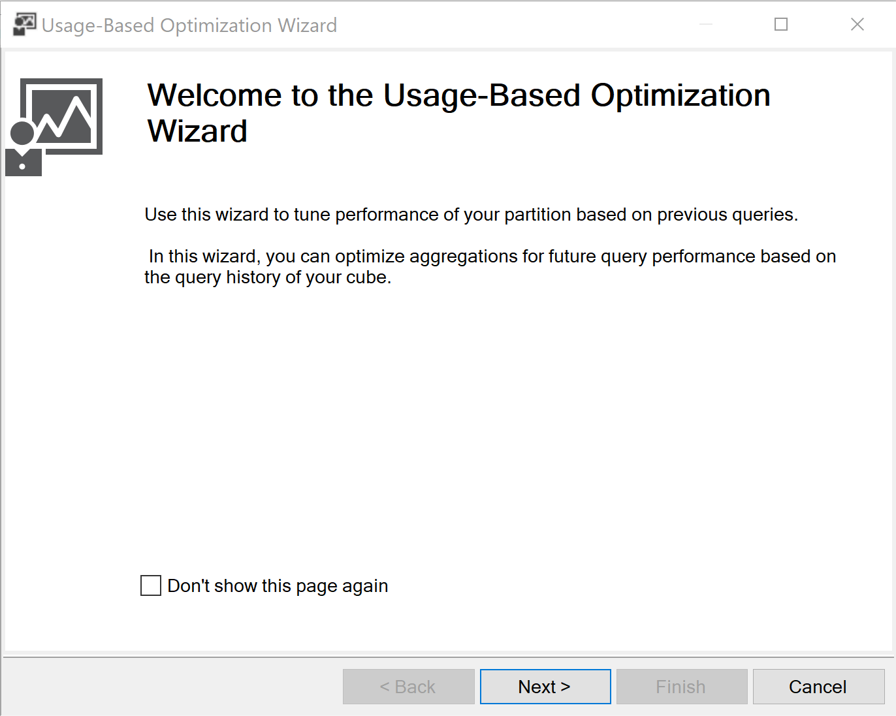

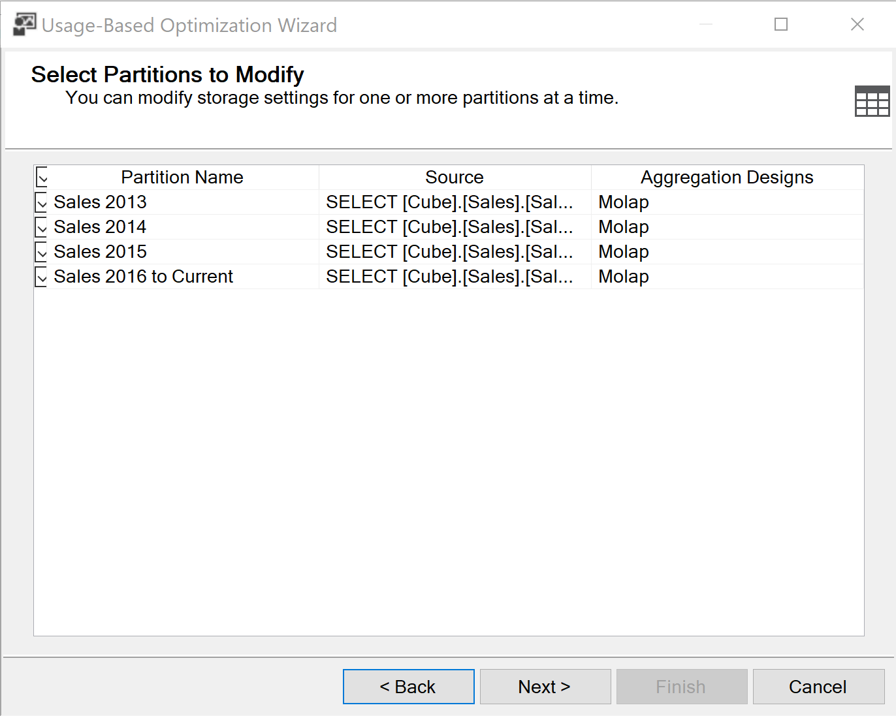

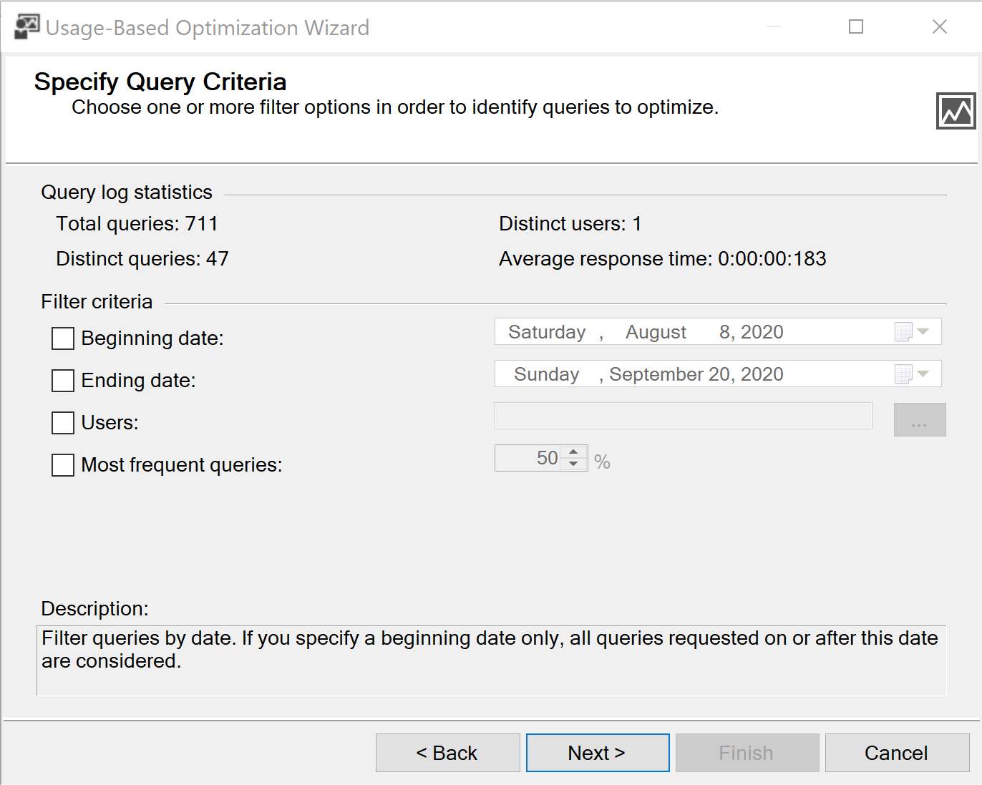

Your error occurred here. This is likely due to the inability to connect to the database with the logs.

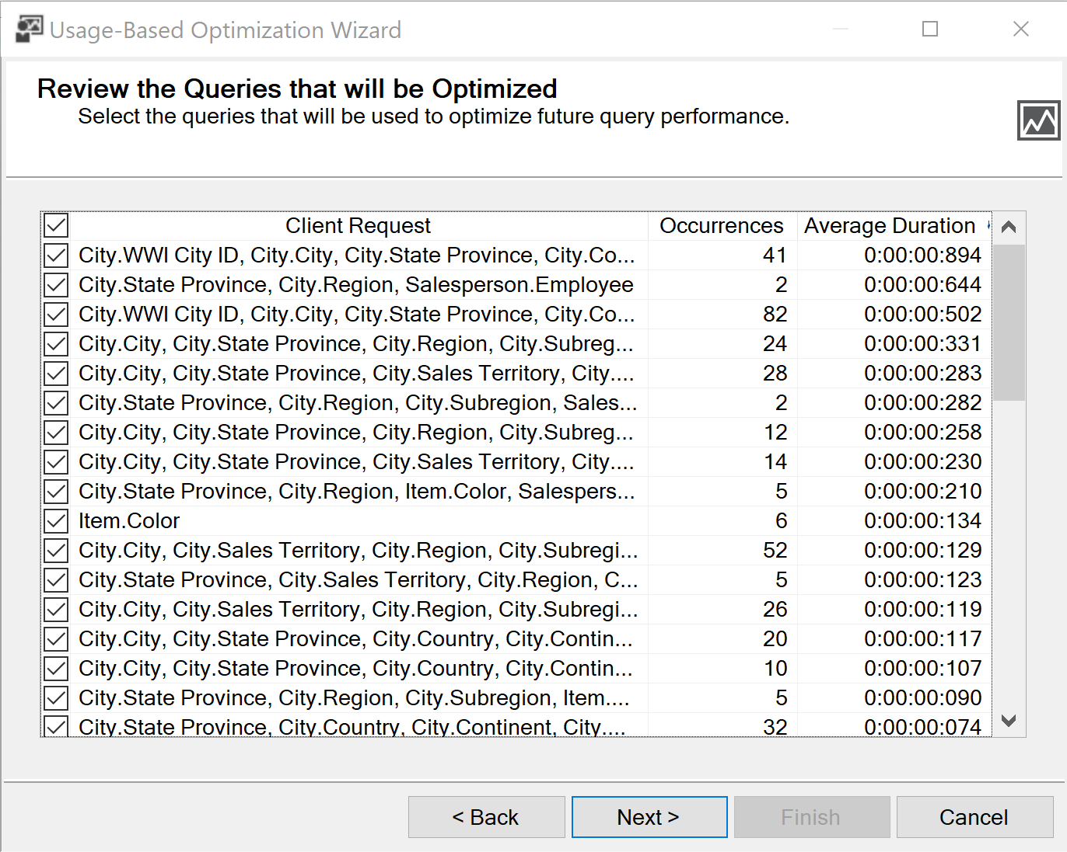

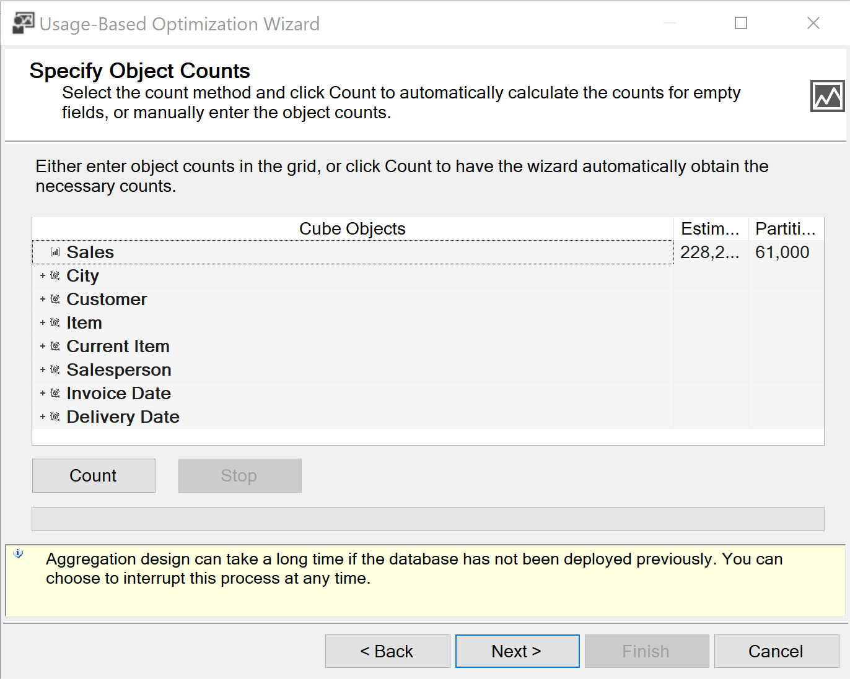

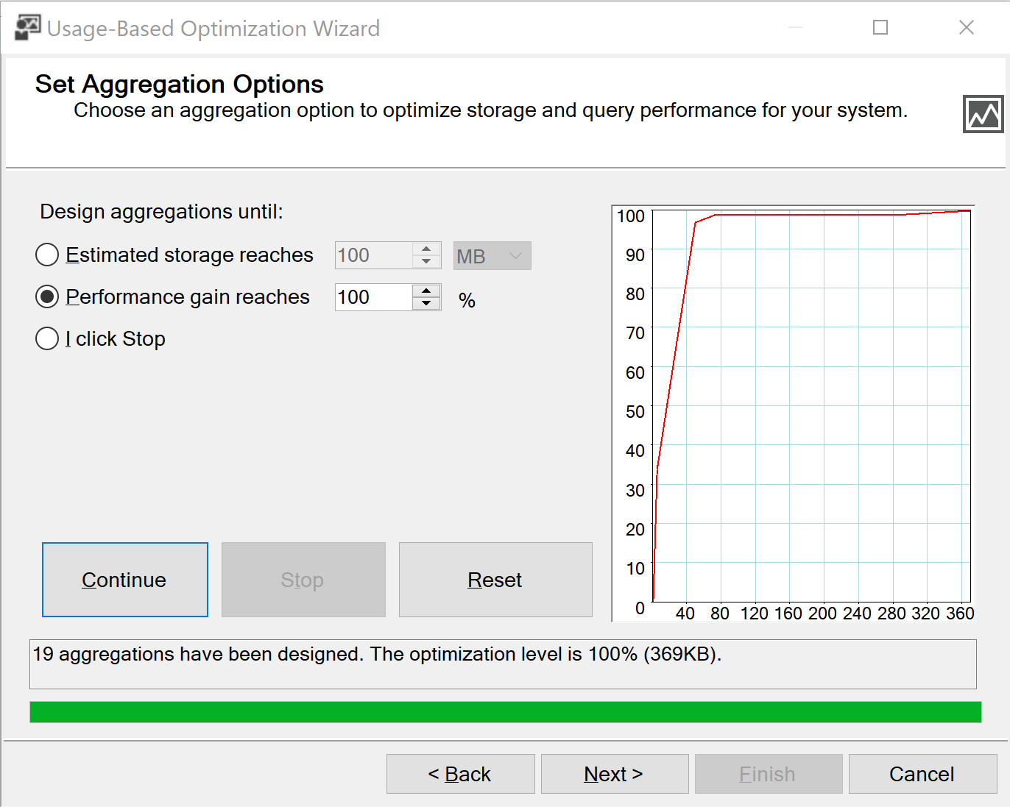

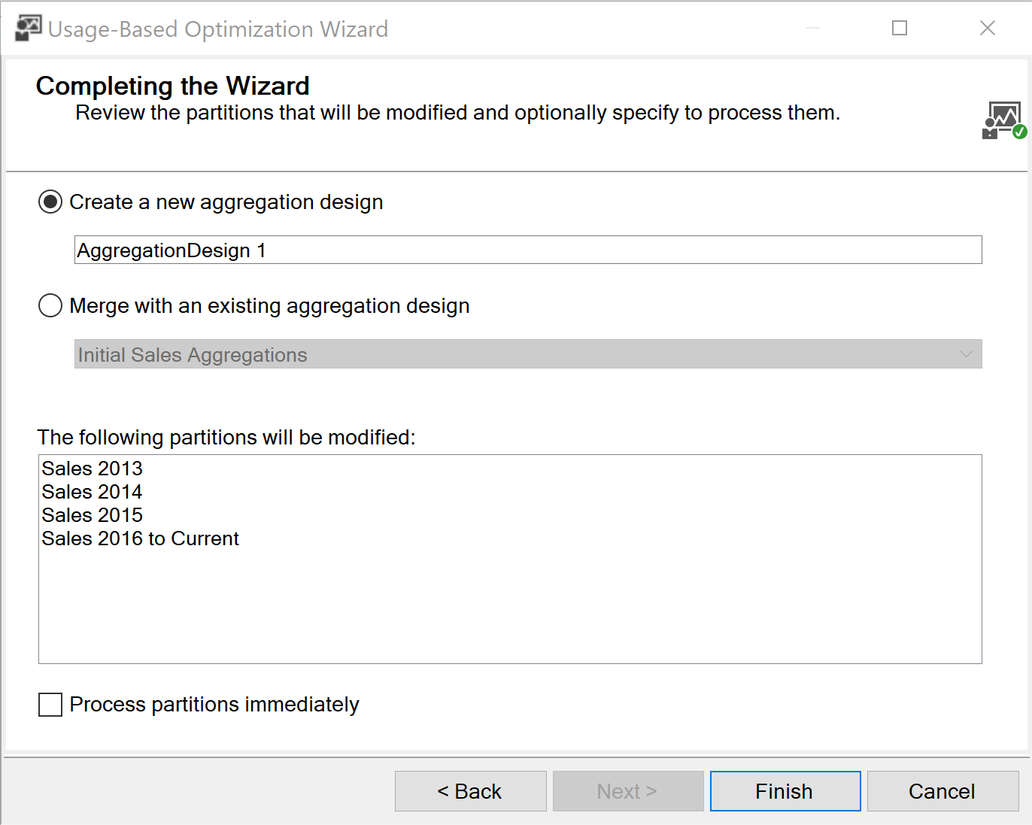

Click Finish and done